 | Mathematics Applications Units 3 and 4  Test 4 Semester 1 2018  TIME: 45 minutes  Marks: 46 | 

NAME: ________________________________________

Formula : Euler’s Rule V + F = E + 2

- [3 marks]

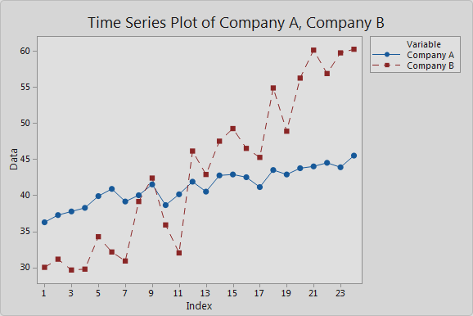
The graph below shows car sales for 2 companies over a 2 year period. Compare any trends or patterns shown between the two sets of data and comment on which is more suitable for linear regression. Justify your answer.

- [2, 3, 2, 1, 2 marks]
The unemployment figures for a small country over a period of 3 years (2012 – 2014) are provided in the following table

Time | Date | Unemployment Figure  (nearest thousand) | Yearly  Mean | Percentage of Yearly Mean
1 | Mar 2012 | 39 000 | 52500 | 74.3%
2 | Jun 2012 | 58 000
3 | Sep 2012 | 74 000
4 | Dec 2012 | 39 000
5 | Mar 2013 | 41 000 | 57000 | 71.9%
6 | Jun 2013 | A |  | C
7 | Sep 2013 | 78 000
8 | Dec 2013 | 48 000
9 | Mar 2014 | 43 000 | B | 71.1%
10 | Jun 2014 | 70 000
11 | Sep 2014 | 79 000
12 | Dec 2014 | 50 000

        - How many points should the moving average be to smooth the data set? Justify your answer.

        - Determine the values of A, B and C in the table above.

        - Calculate the centred four-point moving average for June 2014.

        - The seasonal indices for three of the quarters are shown in the table below.
Calculate the seasonal index for September.

Quarter | March | June | September | December
Seasonal  Indices | 0.724 | 1.111 |  | 0.804

        - Find the deseasonalised unemployment figure for March 2012, correct to the nearest thousand.

- [2, 2, 5, 2 marks]

Sales of soup at a school canteen for the first three weeks of Term 3 are shown in the table below.

 | Time(n) | Week | Day | # Sales | 5pt M.A.
 | 1 |  | M | 65 | -
 | 2 |  | T | 40 | -
 | 3 | 1 | W | 50 | 56
 | 4 |  | Th | 55 | 57
 | 5 |  | F | 70 | 59
 | 6 |  | M | 70 | 60
 | 7 |  | T | 50 | 62
 | 8 | 2 | W | 55 | 62
 | 9 |  | Th | 60 | 63
 | 10 |  | F | 75 | 63
 | 11 |  | M | 75 | 64
 | 12 |  | T | 50 | 65
 | 13 | 3 | W | 60 | 66
 | 14 |  | Th | 65 | -
 | 15 |  | F | 80 | -

        - Find the equation of the least squares regression line of the five point moving average (M) against time (n).

        - Use the average percentage method to calculate the seasonal index for Friday.

        - Predict the expected number of soup sales for Friday of week 6. Comment on the reliability of this prediction stating reasons for your answer.

(d) Would you expect this trend to continue? Justify your answer.

4. (12 marks)
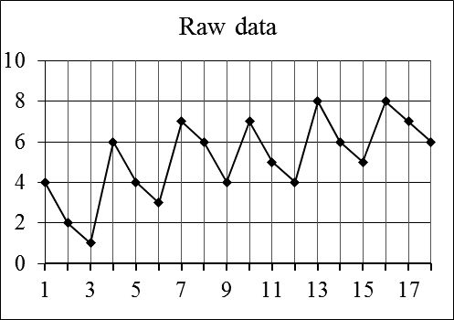
(a) Consider the following data and the graph of the data.
 | Raw | 3 CMA
Counter | data | (2 d.p.)
1 | 4
2 | 2 | 2.3333
3 | 1 | 3
4 | 6 | 3.67
5 | 4 | 4.33
6 | 3 | 4.67
7 | 7 | 5.33
8 | 6 | 5.67
9 | 4 | 5.67
10 | 7 | 5.33
11 | 5 | 5.33
12 | 4 | 5.67
13 | 8 | A
14 | 6 | 6.33
15 | 5 | 6.33
16 | 8 | 6.67
17 | 7 | 7
18 | 6

(i) Carefully explain why a three point moving average is used. (3)

(ii) Calculate the value of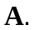 Show your working. (3)

(iii) Plot the 3MA on the graph. (3)

(b) Consider the following data and the graph of the data.
 |  | Counter | Raw data | 12 CMA (2 d.p.)
2014 | Jan | 1 | 1
 | Feb | 2 | 2
 | Mar | 3 | 3
 | Apr | 4 | 5
 | May | 5 | 6
 | Jun | 6 | 7
 | Jul | 7 | 8 | 4.46
 | Aug | 8 | 5 | 4.67
 | Sep | 9 | 5 | 4.96
 | Oct | 10 | 4 | 5.13
 | Nov | 11 | 3 | 5.25
 | Dec | 12 | 2 | 5.38
2015 | Jan | 13 | 3 | 5.58
 | Feb | 14 | 4 | 5.71
 | Mar | 15 | 6 | 5.96
 | Apr | 16 | 6 | 6.08
 | May | 17 | 7 | 6.13
 | Jun | 18 | 8 | 6.17
 | Jul | 19 | 10
 | Aug | 20 | 8
 | Sep | 21 | 8
 | Oct | 22 | 6
 | Nov | 23 | 4
 | Dec | 24 | 3

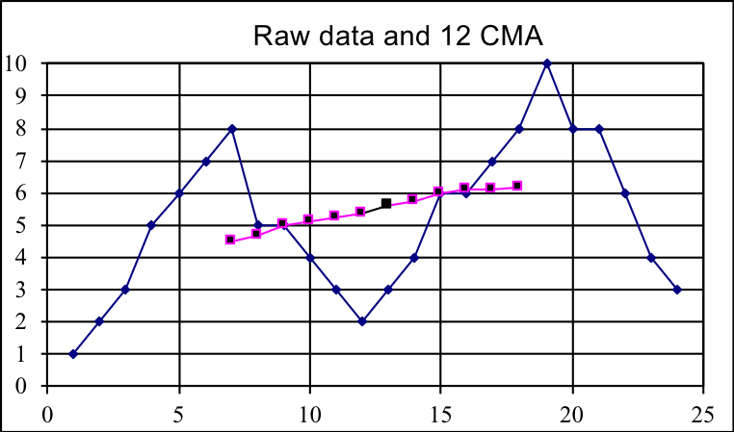

(i) Explain why so many scores have no moving average value. (2)

(ii) Find the seasonal index for January 2014. (3)

(iii) Find the equation of the least-squares line using the 12 CMA and the
counter. (3)

(iv) Use the equation in (ii) to predict the raw data for January 2016. (2)

(v) Explain carefully how you would seasonally adjust your prediction in (iii) (3)

End of Test

